

COMPUTER NETWORKS

EXP 14



November 2, 2021

Roehit ranganathan

RA1911033010017 | L2

# HDLC CONFIGURATION

## Aim:

To implement HLDC Configuration using Cisco Packet Tracer.

## Diagram:

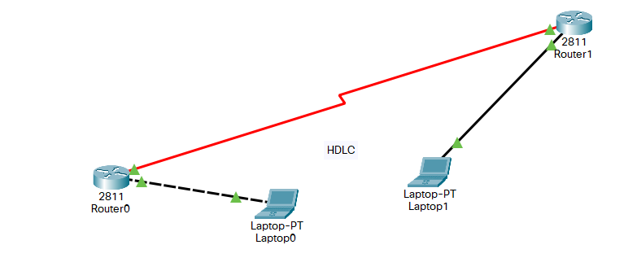

## Procedure:

Create the setup as shown in the following figure and configure everything according to it.



## 1. Use the connected laptops to find the DCE and DTE routers

Router-A#show controllers serial 0/3/0

Interface Serial0/0/0

Hardware is PowerQUICC MPC860

DTE V.35 TX and RX clocks detected

Router-B#show controllers serial 0/3/0

Interface Serial0/3/0

Hardware is PowerQUICC MPC860

DCE V.35, clock rate 250000

In this example, Router-A is the DTE side, and Router-B the DCE side



## 2. Configure the routers with the following parameters

Router-B being the DCE, clock rate has to be configured on Router-B serial 0/3/0 interface

Router-B(config)#interface serial 0/3/0

Router-B(config-if)#clock rate 250000

Then, configure HDLC encapsulation and IP address on Router-B serial 0/3/0 interface. **The encapsulation HDLC** configures HDLC protocol on the serial interface.

Router-B being the DCE side of the serial link, the 192.168.1.5/30 IP address is configured on Router-B serial 0/3/0 interface. Don’t forget to enable the interface with a **no shutdown** command.

Router-B(config)#interface serial 0/3/0

Router-B(config-if)#encapsulation hdlc

Router-B(config-if)#ip address 192.168.10.5 255.255.255.252

Router-B(config-if)#no shutdown

The show interfaces serial 0/0/0 confirms that HDLC encapsulation is enabled on the interface: *Encapsulation HDLC, loopback not set, keepalive set (10 sec)*

Router-B#show interfaces serial 0/3/0

Serial0/3/0 is up, line protocol is up (connected)

Hardware is HD64570

Internet address is 192.168.10.5/30

MTU 1500 bytes, BW 1544 Kbit, DLY 20000 usec,

reliability 255/255, txload 1/255, rxload 1/255

Encapsulation HDLC, loopback not set, keepalive set (10 sec)

Last input never, output never, output hang never

[...]

Finally, configure HDLC encapsulation and IP address on Router-A serial 0/0/0 interface. The link becomes up as both routers are correctly configured.

Router-A(config)#interface serial 0/3/0

Router-A(config-if)#encapsulation hdlc

Router-A(config-if)#ip address 192.168.10.6 255.255.255.252

Router-A(config-if)#no shutdown

## 3. Check IP connectivity between the two routers using the ping command.

Issue a ping from Router-A to Router-B to test network connectivity between the two routers.

Router-A#ping 192.168.10.5

Type escape sequence to abort.

Sending 5, 100-byte ICMP Echos to 192.168.10.5, timeout is 2 seconds:

!!!!!

Success rate is 100 percent (5/5), round-trip min/avg/max = 3/3/4 ms

## RESULT:

HLDC Configuration is successfully implemented and demonstrated.